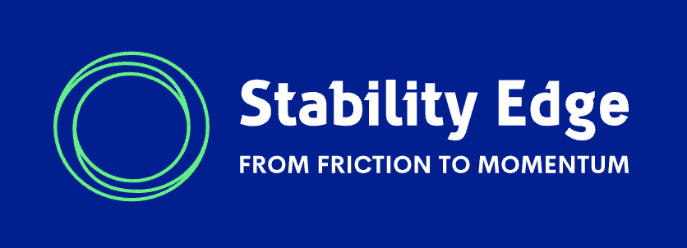

Operational Coherence Index™
Report Suite Guide
  - How to Understand OCI Assessment Outputs, Dashboards, and Diagnostic Reports

Prepared for Executive Sponsors and Leadership Teams
Version 1.0 | 2026

Copyright and Use
Copyright © 2026 Stability Edge, LLC. All rights reserved.
Operational Coherence™, Leadership Control Architecture™, Operational Coherence Index™, Decision Spine™, Execution Cadence™, Visibility Layer™, Friction Radar™, Command Core™, Leader System™, Stability Architecture Advisory™, and Stability Operating System™ are trademarks or proprietary intellectual property of Stability Edge unless otherwise noted.
This guide is intended for executive education, assessment orientation, and client planning. It is not intended as legal, regulatory, financial, or clinical advice. Sample reports are illustrative and should be read as examples of the OCI reporting experience. Actual client reports will reflect the assessment data, participation mix, organizational context, and scope of engagement.

Purpose of This Guide
This guide explains what leaders receive through the Operational Coherence Index™ reporting process, when each output becomes available, what each report is designed to do, and how executives should use the findings.
The Operational Coherence™ Executive Guide explains the framework. It defines Operational Coherence, describes Leadership Control Architecture, introduces the six control points, and explains why healthcare organizations need a stronger leadership architecture during continuous transformation.
This guide serves a different purpose. It explains the reporting experience. It helps executive sponsors, leadership teams, and internal project owners understand how to move from individual assessment results to aggregate dashboard findings, then from dashboard findings to Stability Edge diagnostic interpretation and action planning.
The simplest way to read the OCI report suite is this: the individual result creates personal reflection; the dashboard creates aggregate visibility; the diagnostic report creates executive interpretation; and the debrief turns interpretation into focused action.

How This Guide Fits with the Executive Guide
The Executive Guide should be read first by leaders who want to understand the intellectual and practical foundation of Operational Coherence. This Report Suite Guide should be used after that foundation is clear, especially when a prospect or client is reviewing sample outputs or preparing to launch the assessment.
The Executive Guide answers: Why does Operational Coherence matter, and what leadership architecture preserves it?
This Report Suite Guide answers: What will I receive, when will I receive it, why does each output exist, and how should we use it?
The two guides are companion documents. They should not duplicate each other. The Executive Guide teaches the framework. This guide explains the sequence of reports and the way leaders should interpret them.

Executive Overview: The OCI Reporting Experience
The Operational Coherence Index™ Assessment produces several outputs because different users need different views at different points in the client journey. A single executive completing the assessment needs a personal result. An executive sponsor needs an aggregate dashboard once enough participants have completed the assessment. A leadership team needs downloadable summaries and visuals that make the findings discussable. Stability Edge then uses the aggregate evidence to create a diagnostic interpretation that supports a focused executive debrief and advisory roadmap.
The reports should be understood as a connected suite rather than separate products. Each output adds a different level of insight. None should be treated as the entire diagnostic picture by itself.
1. Individual Result: helps one leader reflect on their own perception of operational coherence.
2. Executive Dashboard: shows aggregate results after sufficient participation.
3. Dashboard Downloads: provide summary, narrative, and visual formats for leadership review.
4. OCI Diagnostic Report: translates patterns into architectural interpretation and improvement opportunities.
5. Diagnostic Slide Deck: supports a facilitated executive debrief and next-step planning.

Why There Are Multiple Report Types
The OCI Assessment does not produce multiple outputs to create complexity. This structure allows each output to do its own job. The reporting experience moves from reflection, to visibility, to interpretation, to action.
Early in the process, the goal is individual engagement. The executive or leader taking the assessment should immediately receive enough feedback to understand their own perspective and see why broader participation matters. At that point, the value is reflection and curiosity, not organizational diagnosis.
After at least five participants have completed the assessment, the reporting experience changes. The executive sponsor can begin reviewing aggregate patterns. This threshold matters because Operational Coherence is an organizational condition, not merely an individual opinion. Multiple responses allow the dashboard to show how leaders are experiencing the organization across functions, levels, and control points.
Once aggregate reporting is available, the dashboard outputs help leaders see the organization at several levels of resolution. A one-page summary creates quick orientation. A detailed dashboard report explains the findings in narrative form. A dashboard slide set makes the findings easier to discuss in an executive meeting.
The Stability Edge Diagnostic Report adds another layer. It is not merely a longer version of the dashboard. It is the consultant-grade interpretation of the evidence. It examines how patterns interact, which risks deserve executive attention, and which improvement opportunities are most likely to strengthen Leadership Control Architecture.

The OCI Reporting Pathway
The reporting pathway follows a natural progression. It begins with the individual experience and ends with focused leadership action. The sequence should be explained to prospects before the assessment begins so they understand why participation matters and what will happen after results are available.

1. Individual Result
An executive or leader completes the OCI Assessment and receives immediate personal results. This creates awareness and gives the participant a first view of how they perceive the organization across the six control points.

2. Aggregate Dashboard
Once at least five participants have completed the assessment, aggregate reporting becomes available to the authorized executive contact. The dashboard shows organizational patterns rather than individual answers.

3. Downloadable Dashboard Outputs
The executive contact can download a one-page summary, a detailed dashboard report, and a slide set of graphs. These outputs support internal review and leadership discussion.

4. Stability Edge Diagnostic Report
Stability Edge reviews the aggregate evidence and generates a diagnostic interpretation. This report identifies architectural patterns, risks, and improvement opportunities.

5. Executive Debrief
Stability Edge facilitates a leadership discussion using the diagnostic report and slide deck. The purpose is to create shared understanding and select the first improvement priorities.

6. Advisory Roadmap
The findings inform the next phase of work, which may include Stability Architecture Advisory™, focused 30/60/90-day improvement work, and future remeasurement.

Report Matrix
The following matrix explains each output in the OCI Report Suite. The names are intentionally simple so executives can quickly understand what they will receive and how each item should be used.
Report / Output | When Available | Primary Audience | Format | Primary Purpose | How to Use It
Individual OCI Result | Immediately after completion | Individual participant | On screen; printable or downloadable | Provides a personal view of how one leader perceives the organization. | Use for reflection and to introduce the value of broader team participation.
Executive Dashboard View | After 5+ participants complete the assessment | Executive sponsor or authorized contact | Online dashboard | Shows aggregate results, control point performance, perception gaps, profile, and risk patterns. | Use to orient the sponsor to the organization-level pattern.
One-Page Executive Summary | From the dashboard after 5+ responses | CEO, executive sponsor, senior team, board-facing sponsor | PDF | Provides a fast snapshot of overall OCI score, organizational profile, control points, perception gaps, risk heat map, narrative, and top priorities. | Use as a briefing page or discussion starter.
Detailed Executive Dashboard Report | From the dashboard after 5+ responses | Executive sponsor and senior leadership team | PDF | Provides a fuller narrative interpretation of the aggregate dashboard findings. | Use for internal review before the Stability Edge diagnostic debrief.
Executive Dashboard Slide Set | From the dashboard after 5+ responses | Executive team or transformation leadership group | Slides / PDF | Presents graphs and visuals in a meeting-ready format. | Use to facilitate internal conversation about the data.
OCI Diagnostic Report | Generated by Stability Edge after aggregate review | Executive leadership team | PDF | Provides consultant-grade architectural interpretation, risk analysis, priority opportunities, and action guidance. | Use as the primary document for debrief, prioritization, and advisory planning.
OCI Diagnostic Slide Deck | Generated by Stability Edge for debrief | Executive team in facilitated session | Slides / PDF | Presents diagnostic findings in a facilitated executive format. | Use to align leaders and define the first 30/60/90-day work.

How to Read the Individual OCI Result
The individual result is the first output a participant sees. It is designed to create immediate insight without pretending to diagnose the whole organization from one person’s perspective. It shows how that participant perceives the current condition of the organization across the six control points.
The individual result is useful because it gives executives a personal experience of the assessment. A sponsor who completes the assessment can immediately see the logic of the framework and understand why broader participation is necessary. The result should help the participant ask better questions, not draw premature conclusions.
Individual results should not be used to evaluate a leader, compare individuals, or infer organizational truth from one response. The assessment becomes more powerful when multiple leaders participate and the system can identify aggregate patterns, perception gaps, and recurring evidence across the leadership group.
• Use the individual result as a personal reflection tool.
• Do not treat one individual result as an organizational diagnosis.
• Use the result to invite broader participation from leaders who hold different views of the organization.

How to Read the Executive Dashboard Outputs
The executive dashboard becomes available after sufficient participation. At that point, the assessment shifts from individual reflection to aggregate visibility. The dashboard is designed to help the executive sponsor see the organization as a system, not as a collection of isolated responses.
The dashboard view should answer several questions quickly: What is the overall OCI score? Which control points appear stronger or weaker? Are different leadership levels seeing the organization differently? What profile best summarizes the current operating pattern? Which risks appear most acute? Which priorities should leadership discuss first?
The dashboard outputs should be read as a structured baseline. They are strong enough to begin an executive conversation, but they are not the final interpretation of the work. The diagnostic report and executive debrief add context, architectural reasoning, and prioritization.

The One-Page Executive Summary
The one-page executive summary is designed for fast orientation. It should allow a CEO, sponsor, board-facing executive, or leadership team member to understand the basic picture in a few minutes.
This output typically includes the overall OCI score, organizational profile, six control point scores, perception gaps, risk heat map, executive narrative, and top improvement priorities. Its value is compression. It does not explain everything. It shows enough to focus attention.
Use the one-page summary when a leader needs a quick briefing or when the sponsor wants to introduce the findings before a deeper discussion.

The Detailed Executive Dashboard Report
The detailed executive dashboard report provides a fuller narrative summary of the aggregate dashboard findings. It gives more context than the one-page summary while still remaining an automated dashboard output.
This report is useful for executive sponsors and internal owners who need time to review the findings before a facilitated debrief. It should help them understand the basic pattern, the risk landscape, and the likely areas requiring leadership attention.
This report should not be confused with the Stability Edge Diagnostic Report. The dashboard report summarizes the aggregate findings. The diagnostic report interprets the findings architecturally and connects them to improvement work.

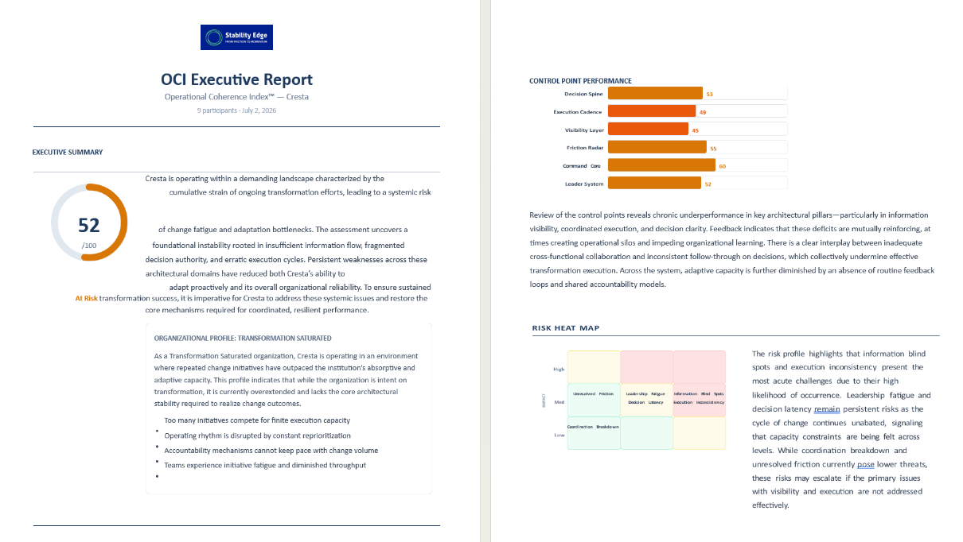

The Executive Dashboard Slide Set
The dashboard slide set provides a visual version of the aggregate findings. It is designed for meetings where leaders need to see the patterns together. The slide set can include score visuals, control point comparisons, perception gap displays, risk heat maps, and other charts drawn from the dashboard.
Use the dashboard slide set to begin internal discussion. It is especially useful when the sponsor wants to socialize the findings with a leadership group before the Stability Edge diagnostic debrief.

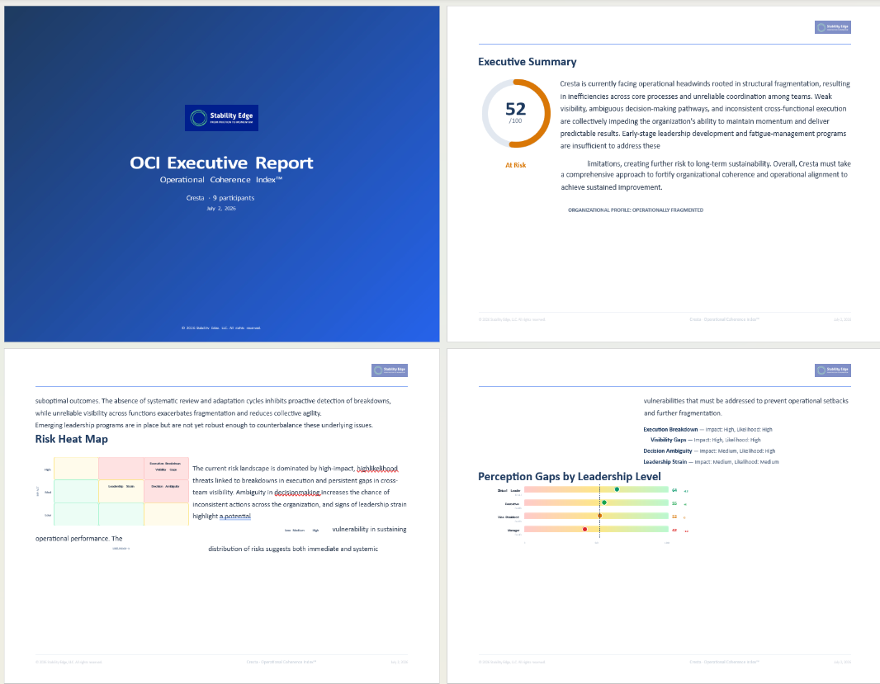

How to Interpret Scores Without Over-Focusing on Numbers
The OCI score matters. It creates a baseline, gives executives a common reference point, and allows future reassessment. It also helps leaders understand whether the organization is generally coherent, resilient with friction, strained, structurally weak, or at critical risk.
But the score is not the diagnosis. The score is a signal. The pattern is the diagnosis.
A health system can have the same overall OCI score as another organization while facing a very different architectural problem. One may be constrained by decision congestion. Another may be struggling with visibility gaps. Another may have a strong executive team but weak operating cadence. Another may show wide perception gaps between senior leaders and managers. The number helps locate the organization on a scale; it does not explain why the organization is there.
The strongest reading of OCI results moves in this order: evidence, scores, patterns, profile, narrative, priorities. Leaders should resist the temptation to jump from score directly to solution. A low score in one control point may not be the best place to begin if another pattern is creating greater system-wide drag.
• Use the overall score as a baseline, not a grade.
• Use the control point scores to identify where architecture may be under strain.
• Use perception gaps and variability to understand where leaders experience the organization differently.
• Use the narrative and diagnostic interpretation to understand how the patterns interact.
• Use priority recommendations to decide where leadership action should begin.

How to Read Performance Bands
Performance bands are intended to make the score easier to interpret. They describe the current condition of operational coherence at a broad level. They should not be used as labels placed permanently on the organization.
Score Band | Interpretive Label | How to Read It
80-95 | Coherent | The leadership architecture appears to preserve coordinated action effectively under pressure.
65-79 | Resilient with Friction | The organization is generally holding together, but important friction or strain is visible.
50-64 | Strained | The organization remains functional, but coherence requires increasing effort and leadership attention.
35-49 | Significant Structural Weakness | Leadership architecture is not reliably preserving coordination, visibility, and execution.
0-34 | Critical Risk | The organization shows severe architectural weakness that may threaten sustained performance.

How Perception Gaps Should Be Read
Perception gaps are among the most important elements of the OCI report suite. They show whether leaders at different levels, functions, or locations are experiencing the organization in the same way.
A perception gap does not prove that one group is right and another group is wrong. Executives may see enterprise priorities and governance structures more clearly. Managers may see workflow friction, workaround patterns, and operational drag earlier. Clinical leaders may see adoption strain that does not yet appear in formal reporting. Technology leaders may see system constraints that operational leaders experience only as delay.
The value of a perception gap is not accusation. The value is inquiry. When senior leaders rate a control point much stronger than managers, the leadership team should ask what senior leaders may not be seeing. When managers rate an area more positively than executives, the organization should ask whether local adaptation is stronger than enterprise reporting suggests.
Perception gaps help leaders find where reality may be moving unevenly through the organization. In that sense, they are often early warning signals. A large gap may indicate visibility problems, truth flow barriers, inconsistent operating conditions, or differences between formal design and lived experience.
• Do not use perception gaps to blame a group.
• Use perception gaps to ask where the organization is seeing itself unevenly.
• Look for repeated gaps across several control points rather than overreacting to one difference.
• Ask whether the gap reflects different information, different incentives, different exposure, or different levels of operational strain.

What the OCI Diagnostic Report Adds
The OCI Diagnostic Report is the premium interpretive artifact in the report suite. It is generated by Stability Edge after reviewing the aggregate evidence and is intended to support an executive debrief, priority selection, and advisory roadmap.
The diagnostic report adds value because it moves beyond describing the data. It explains what the data suggests about the organization’s Leadership Control Architecture. It identifies the architectural issue underneath the symptoms, the risks that may follow if the pattern continues, and the highest-value opportunities for improvement.
For example, a dashboard may show weak scores in Decision Spine and Execution Cadence. The diagnostic report may interpret that combination as a pattern of aligned senior intent trapped inside slow-moving decision pathways and status-heavy meeting structures. That interpretation is more useful than the scores alone because it helps leaders understand what must change in the architecture.
The diagnostic report may include an executive summary, what was observed, key organizational patterns, architectural interpretation, organizational profile, organizational risks, risk heat map, priority improvement opportunities, trajectory, assessment confidence, and detailed scoring appendix.

Architectural Interpretation
Architectural interpretation is the central contribution of the diagnostic report. It answers: what does this evidence suggest about how the leadership system is functioning?
This interpretation connects the six control points rather than treating them separately. Decision Spine, Execution Cadence, Visibility Layer, Friction Radar, Command Core, and Leader System operate as a system. Weakness in one area often affects the others. The diagnostic report explains those interactions.

Prioritization
The diagnostic report helps leaders avoid the common mistake of fixing the lowest score first. The lowest score may be important, but it may not be the highest-leverage starting point. Stability Edge prioritizes improvement opportunities based on system effect, urgency, feasibility, dependencies, and leadership readiness.
A first priority should create movement. It should reduce strain, improve visibility, clarify decisions, or strengthen cadence in a way that makes additional improvements easier.

30/60/90-Day Action Planning
The diagnostic report should lead to a practical improvement sequence. The first 30 days typically focus on clarifying the highest-leverage architectural issue and creating immediate leadership discipline. The first 60 days should begin redesigning selected routines, pathways, or forums. The first 90 days should establish enough repetition that the new discipline can become part of the leadership operating rhythm.
• 30 days: clarify the priority, name owners, define the operating change, and remove obvious friction.
• 60 days: redesign the selected leadership routine, pathway, or visibility mechanism and begin disciplined use.
• 90 days: evaluate whether the change is improving coherence and decide what should be sustained, adjusted, or expanded.

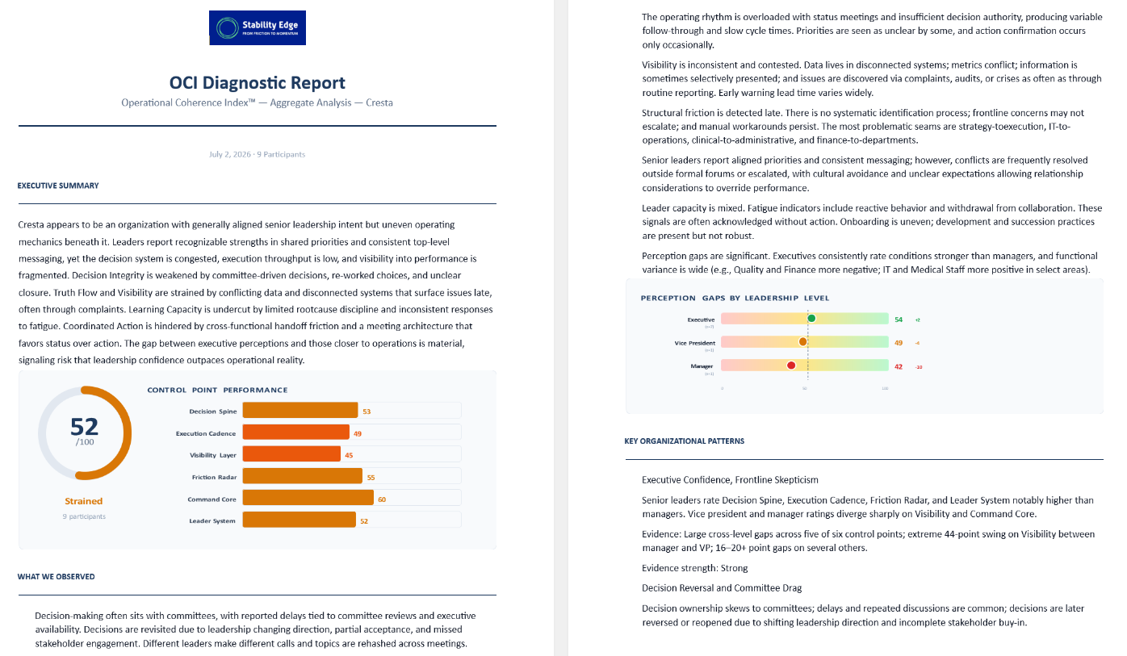

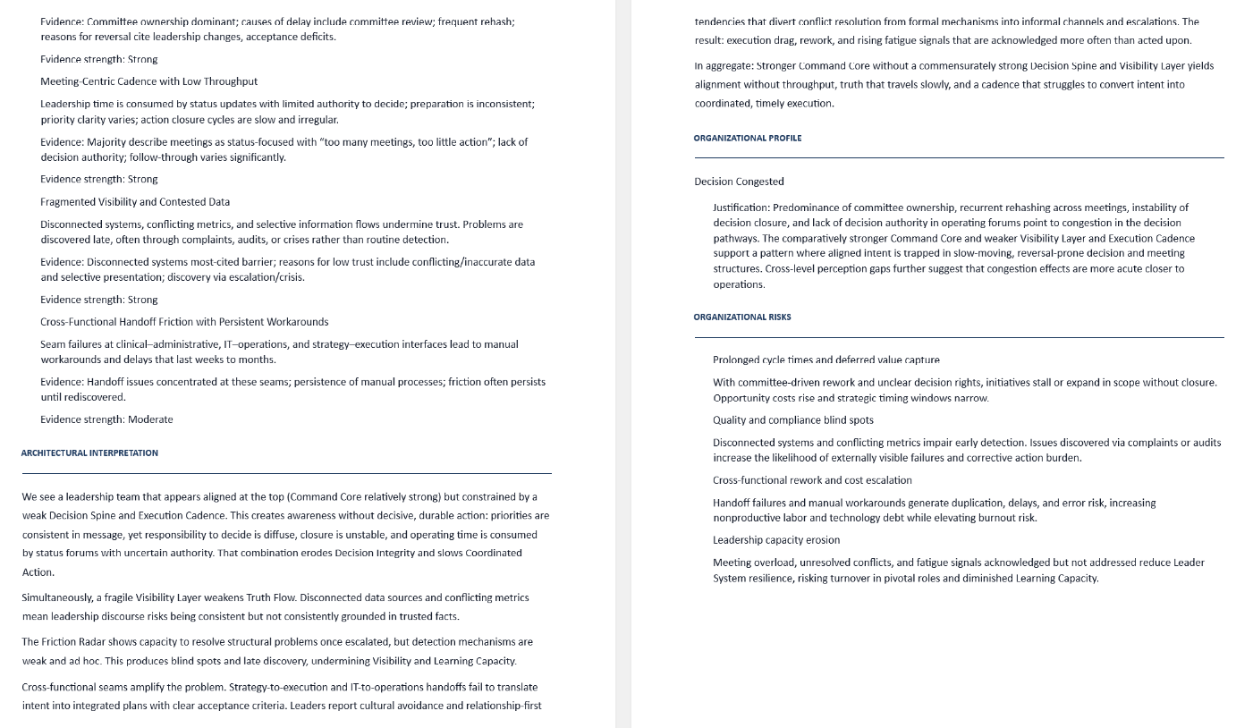

How to Use the OCI Diagnostic Slide Deck
The diagnostic slide deck is the facilitated presentation version of the diagnostic report. Its purpose is not simply to display charts. Its purpose is to help an executive team build shared understanding and make decisions about where to begin.
The best debriefs do not turn into debates about whether a score is perfect. They use the evidence to ask better leadership questions. Where are we stronger than expected? Where are we relying on personal effort instead of architecture? Which risks are being detected late? Which decisions are reopening? Which handoffs are creating rework? Which leadership routines should change first?
The slide deck should be used in a structured executive conversation. The goal is alignment around the pattern, not agreement with every phrase. Once the leadership team agrees on the pattern that matters most, the work can move to priority selection and advisory planning.

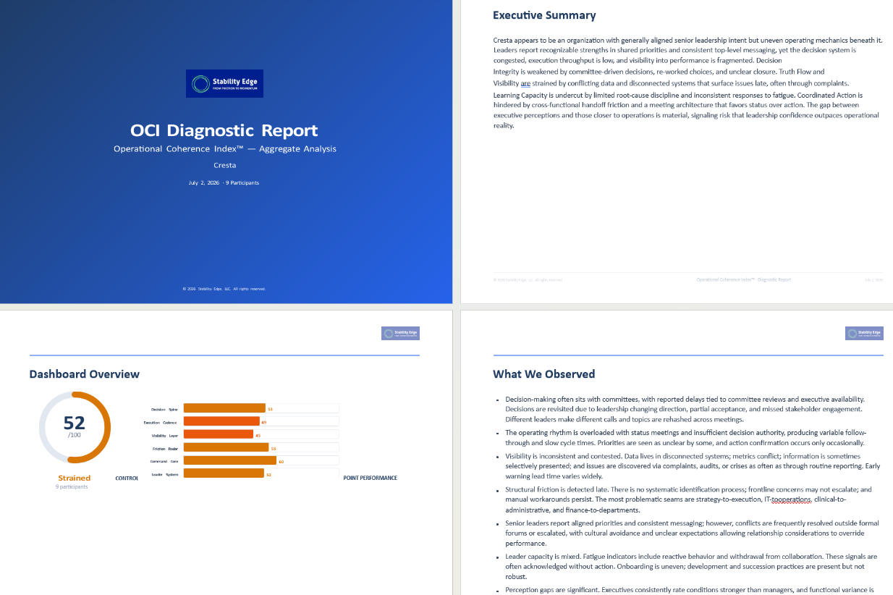

How Confidentiality Works
The OCI Assessment depends on candor. Participants need to know that the purpose of the assessment is to identify organizational patterns, not evaluate individual performance.
Individual responses should not be used to criticize, score, or compare individual leaders. Aggregate reporting is designed to show patterns across groups, functions, levels, and control points. When results are shared, they should be discussed as system signals rather than personal judgments.
For small executive groups, absolute anonymity may be difficult to guarantee because participants may represent distinct roles or functions. The stronger and more accurate promise is disciplined confidentiality. That means individual responses are not used as personal performance evidence, and findings are reported in ways that support organizational learning rather than blame.
Sponsors should explain confidentiality before the assessment begins. They should emphasize that honest input is necessary because leadership teams cannot strengthen what they cannot see. The assessment creates value only when participants describe operational reality as accurately as possible.
• The assessment is designed to evaluate leadership architecture, not individual performance.
• Reports should focus on aggregate patterns and perception differences, not individual answers.
• Comments and examples should be handled carefully, especially in small groups.
• The executive sponsor should set expectations about candor, confidentiality, and constructive use before launch.

What Happens After the Reports
The report suite is valuable only if it leads to better executive conversation and focused architecture improvement. The intended sequence is: OCI debrief, priority selection, Stability Architecture Advisory™, and possible remeasurement.

OCI Debrief
Stability Edge reviews the findings with the executive team, explains the strongest patterns, and helps leaders understand the architectural interpretation.

Priority Selection
The leadership team selects the first improvement priority based on leverage, risk, feasibility, and readiness. The priority should be specific enough to act on within 30 days.

Stability Architecture Advisory™
Stability Edge supports leaders as they strengthen the relevant control points. Advisory work may involve decision architecture, operating cadence, visibility mechanisms, friction detection routines, escalation pathways, Command Core design, or Leader System support.

Remeasurement
A follow-up OCI Assessment may be used to determine whether coherence is improving, stable, or deteriorating. Remeasurement is most useful after enough time has passed for new leadership routines to take hold.

Suggested Use by Audience
Audience | What They Should Review | Best Use
Executive Sponsor | Individual result, dashboard view, all downloadable outputs, diagnostic report. | Understand the full reporting pathway and prepare the leadership team for debrief.
CEO / Senior Executive Team | One-page summary, diagnostic report, diagnostic slide deck. | Focus on the dominant pattern, priority risks, and first leadership actions.
Transformation / PMO Leader | Detailed dashboard report, dashboard slide set, diagnostic report. | Connect findings to initiative governance, cadence, escalation, and execution routines.
Clinical / Operational Leaders | One-page summary, perception gaps, diagnostic findings. | Discuss how operational reality is moving through the leadership system.
Board-Facing Sponsor | One-page summary and selected diagnostic themes. | Brief governance stakeholders without overloading them with assessment mechanics.

Common Misreadings to Avoid
Treating the OCI score as a grade: The score is a baseline and signal. It should focus attention, not create defensiveness.
Assuming the lowest score is automatically the first priority: The highest-leverage priority may be the issue that most strongly affects several control points.
Using perception gaps to identify who is wrong: Perception gaps show differences in experience and visibility. They should prompt inquiry.
Confusing the dashboard report with the diagnostic report: Dashboard outputs summarize aggregate results. The diagnostic report provides architectural interpretation and prioritization.
Expecting one assessment to prove trajectory: Trajectory requires repeated measurement or strong time-based evidence. A first assessment establishes a baseline.
Treating the assessment as an employee engagement survey: The OCI Assessment is an executive diagnostic of leadership control architecture, not a general engagement survey.

Executive Questions for Reading the Report Suite
The most productive executive teams use the OCI Report Suite to ask better questions. The following questions can guide review of the sample reports and actual client findings.
• What pattern appears repeatedly across several outputs?
• Where do scores, narratives, and perception gaps reinforce one another?
• Where do senior leaders and managers appear to experience the organization differently?
• Which control point weakness is creating the greatest drag on the others?
• Where are we relying on executive effort instead of leadership architecture?
• Which finding, if addressed in the next 30 days, would create the most useful movement?
• What leadership routine should we redesign first?
• What evidence would tell us that Operational Coherence is improving?

Recommended Sample Report Packet
When sharing sample materials with prospects, Stability Edge should present the reports as a suite rather than as unrelated documents. A recommended sample packet includes:
• Operational Coherence™ Executive Guide
• Operational Coherence Index™ Report Suite Guide
• Sample Individual OCI Result
• Sample One-Page Executive Summary
• Sample Detailed Executive Dashboard Report
• Sample Executive Dashboard Slide Set
• Sample OCI Diagnostic Report
• Sample OCI Diagnostic Slide Deck
• Summary of OCI Assessment Design and Validity
The packet should be introduced simply: the Executive Guide explains the framework; the Report Suite Guide explains the reporting experience; the sample reports show what leaders receive; the methodology summary explains why the assessment produces useful data.

Closing Perspective
The OCI Report Suite is designed to help healthcare leaders move from intuition to evidence, from evidence to pattern recognition, and from pattern recognition to focused architecture improvement.
The reports should not be used to label an organization or judge individual leaders. They should be used to create a better leadership conversation about how the organization sees reality, makes decisions, coordinates action, detects friction, aligns leadership, and sustains leadership capacity under pressure.
The ultimate value of the report suite is not the number on the first page. The value is the executive clarity that follows: where coherence is strong, where strain is accumulating, what pattern matters most, and what leadership architecture must be strengthened next.
The score opens the conversation. The pattern focuses it. The diagnostic report interprets it. The debrief turns it into action.

